GREEN PAPER

How to
maximize political revenues





WHITE PAPER

Building political ad revenues

Contents

1. Introduction - 3

2. Finding the buyers - 4

3. Understanding the competition

• TV…5
• Radio…7
• Post office...8
• Newspapers…9
• Mobile…13

4. Pricing and packaging - 14

5. Case Study 1 – Richmond Media Group - 15

6. Case study 2 –Tricks and tips from the La Times - 19

7. Conclusion – 21

8. Resources – 21

Introduction

While 2014 is not a presidential election year, the mid-terms promise to be the most expensive in history.

In total campaigns will spend an estimate $6 billion this summer and fall on 435 seats in the U.S. House of Representatives, 33 U.S. Senate seats, 38 state and territorial governorships, 46 state legislators – plus numerous issue-oriented ballots and local races.

Even if political revenues per media company are increasing, consultants say they could increase even more with a better game plan and a systematic approach. The biggest winners in 2014, if 2012 is any example, will be newspapers, whose share is expected to increase to 10% of the total and eclipse radio. Television will lose 5%, from 55% to 50%. That does not sound like much, but its $300 million in revenues.

Research for this report came from a variety of sources, including Tom Edmonds, Edmonds & Associates; John Kimball, John Kimball Group who are consultants to the newspaper industry.

1. Contacting all the buyers

Going after local political dollars means more aggressive sales efforts. National reps should be assigned to focus on the Pac and SuperPacs; while a local effort needs to go deep – all the way to the local sheriff or school board. Reach out to the political marketers early and often. There are two simple ways to make sure you have every contact – and know which ones are spending.

The first step – and one recommended by the LA Times and Richmond Media Group – is to simply purchase the list from John Kimball Group for $500. It goes deep in to the market – down to the sheriff and school board level– and also provides a list of the contacts for the top 260 SuperPacs.

Second, make sure you contact TV and radio stations for “whose buying now,” they willingly give up this information as they are legally required to do so.

If you don’t have a budget for finding contacts, another free way is to Google the Federal Election Commission, click on your state, and get the information directly. The state election commission also has a web site that shows names of candidates and who places the media buys.

Finally there are political journals such as Roll Call, Politico, The Hill that follow specific PAC and campaign spending in important races.

2. Understand the competition

All political spending is competitive and television still gets the lion’s share. Combined with cable, television has a 50% share of all political ads, followed by direct mail, radio and newspaper. There are some major shifts in spending this year, with newspapers on the rise. Here
are some strengths and weaknesses of the three main types of media and how to sell against them.

Television

As mentioned, television continues to dominate political advertising and it is not likely that this is going to change. Top strengths of television:

- Television is where 67% of people say they get their political information. Broken out into segments (below)
Fox is the top source with 44% share of people who answered this question, followed by cable, with 33%, and networks with a combined 37%.

- Marketers like the high emotional impact of television ads

- Personal – Candidates can talk to viewers

However television also has some drawbacks for a media planner:

- Limited inventory. Once television is sold out, the buyers are looking for other ways to reach audiences that have impact.

- Though TV is still number one place people look online for political news, newspapers have the dominant websites. In the mobile space, television and newspapers as dead even.

- Video can easily be reformatted (see Mixpo.com) for the web, leveling the playing field.

- Network news viewership is falling. Its share down from 32% in 2008 to 26% in 2012. Local television share of audience dropped from 40% to 32% and cable was also down.

- Commercials are routinely skipped or stripped out of shows

- Newspapers have equal reliability levels and “turn to” ratings for mobile sites.

Still, television is so dominant that consultants recommend that other media focus on weaker competitors, and only take on television to acquire dollars during sell-out.

Print companies in particular have an opportunity to position themselves early to absorb last minute campaign pushes with their resources such as older voters, ability to distribute printed materials, larger web audiences, and big email lists.

Here is a 2010 study that has not significantly changed:

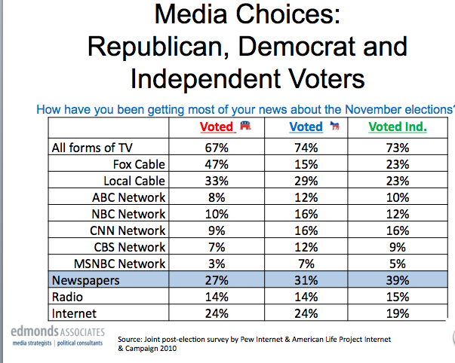

Television is all the number one web site that people turn to for political news:

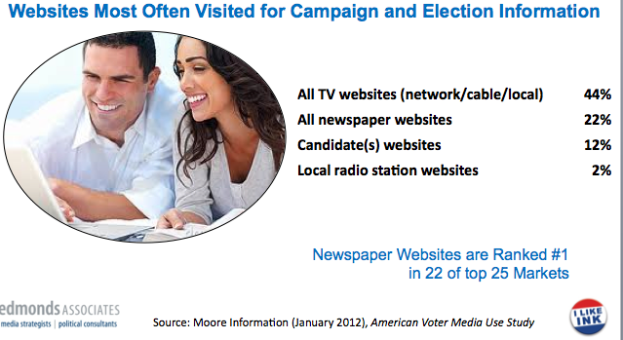

Radio

Radio with 7% to 8% market share, has many of the same strengths of television, but is considered vulnerable to newspapers due to lack of inventory and greater segmentation.

Radio is a high-emotional impact medium that is “easy to buy,” and can launch ads on a “next day basis” providing an outlet for a last minute change of message or added promotion, especially where networks are available. Candidates can deliver a personal voice message to voters. And more people are relying on radio talk as a news sources. Kimball advises “Play on being easy to buy” which takes advantage of the complexity of print, which needs to “become easy. Radio already is.”

Weaknesses include:

- News talk is limited to AM stations, skews republican, and “Preaches to the choir” issue is not as effective for reaching swing voters and democrats

- Most talk shows do not cover local races

- Hyper-local races can’t afford to buy the whole audience

- Competitors cutting into market share

- Most are spot buys, not network

- Weak presence in fast growing internet news sector, where news consumers are shifting, marketers are shifting dollars and print has a lead. Print media with dominant sites in their market, a great demographic match with voters, and the ability to insert printed pieces continue to gain. Especially effective has been the creation of simplified, multi-media packages that has made it easier to buy.

Radio sites can level the playing field by using their strengths – emotional impact, adding geo-targeting capabilities such as text and email (especially if data-mined for voting preferences), personality endorsements and live remotes. Consultants recommend using clear packaging, speed to market and network buys. Look carefully at packaging options, especially going into new multi-media areas.

Direct mail

Direct mail via the U.S. Postage Service has dominated the delivery franchise, securing the second most political ad dollars. People receive their voting registration forms via the mail and/or vote by mail, including the state of Oregon where voting by mail is mandatory. Not coincidentally, direct mail is strong for “get out the vote” messaging and targeting for local races.

However, consultants are advising the more aggressive newspapers to go after market share from this category by using their own distribution networks and packaging in targeted opt-in emails and text alerts with competitive pricing.

Horror stories of the U.S. Post Office delivering campaign materials on a Thursday when a local election was Tuesday, and no recourse to even obtain a refund, have made them especially vulnerable to competition from newspapers who can either insert or deliver printed pieces.

Weaknesses of direct mail via the U.S. Post office include:

- The Post office will not compete on price

- Delivery times are no longer 100% guaranteed – political mail is no longer tagged same as first class

- Newspapers have alternative delivery capabilities that include competitively priced and targeted printing, inserting and/or direct distribution. Snail mail perceived as old school.

Newspapers

As shown here, newspapers have key strengths that should bode well in the 2014 political season and have been much more aggressive in seizing the opportunity. Newspaper revenues from this category have already increased from $50 million in 2002 to $650 million in 2012, as a result of an industry-wide push. Several newspapers have become especially savvy in creating simplified, highly visual bundles; the complexity of the rate card was a key factor preventing many campaign buys.

There are other advantages: Voters are “least annoyed” by newspaper ads, find newspapers the most reliable (but only slightly as we shall see) and are the place where more voters learn about local candidates – rather than national ones – than television. Finally, newspapers can geo-target mailers, have great premium positions and expandable inventory.

Here is a list of newspapers’ competitive strengths, all numbers are from the American Voter Media Use Study:

- Newspaper demographics closely match voters. Voters read and readers vote. Over 80% of voters 35+ are regular newspaper readers and 8 out of ten readers voted in the last two presidential elections. That is, while more people are persuaded by television, people who actually vote are newspaper readers.

- Newspapers are rated most reliable and accurate, ahead of – but about equal with television - but substantially ahead of radio. That is 51% say newspapers are reliable, 50% say television is, but only 44% say radio is.

- Unlimited inventory, a key plus during a peak season.

- Strength in multi—media. Newspaper websites typically dominate in their markets. Newspaper websites are ranked #1 in 22 of 25 largest markets. One third of internet “news” comes from a newspaper.

- Relative strength in political influence. If you break broadcast into individual components, newspapers are second only to television in “how I get my political information” – ahead of radio and internet.

- While TV ads are considered “interruptive” readers consider political ads as a form of news content.

- Unlike television and radio (with the exception of cable), newspapers can geo-target using their distribution vehicles, making them exceptionally efficient, and add print to multi-media buys.

- Due to local political coverage, newspapers are also a natural environment for these ads. Newspapers lead television as most reliable for civic and local issues - 57% to 55% for television and 43% for radio.

- The oft-complained about aging demographic is a strength here, since they are a core group of voters.

Here are some sources for this information:

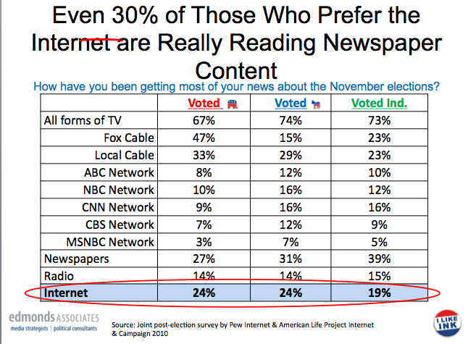
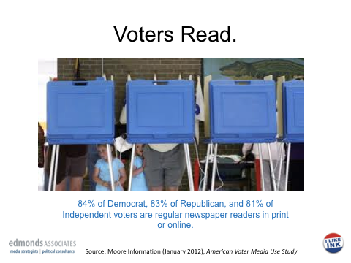

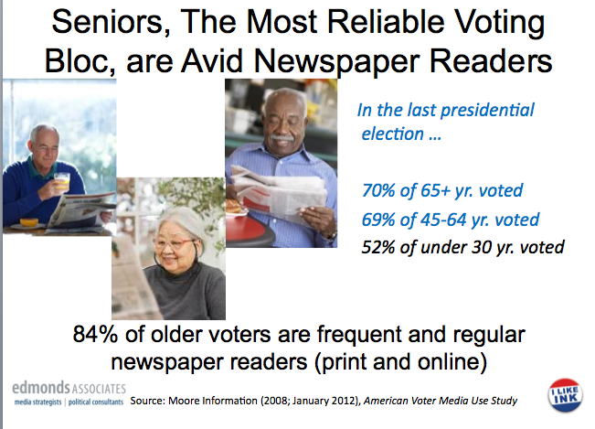

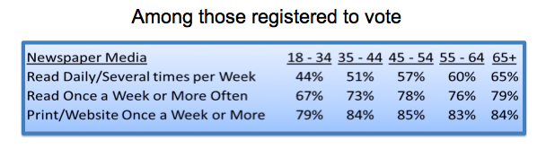
The last chart shows that even younger voters are newspaper readers. Note that 79% of 18 to 34 year old registered voters read a newspaper or newspaper site once a week or more.

The Moore study on how reliable newspapers are as a source is shown below, in comparison to other sources of information:
So newspapers have a great story to tell.

Weaknesses of newspapers:

One weakness of newspapers is simple lack of preparation, due to having conceded this market to television in the past. Here are some other weaknesses:

- Medium lacks emotional impact of broadcast
- Perceived as dinosaurs

- Products and rate cards overly complex, hard to buy

- Late to market issue for local races where there could be a clear advantage

Going mobile: Newspapers catch up

An especially interesting phenomenon happens when political news is consumed on a mobile platform: Newspapers catch up to television. That is, one in four who report planning to use a mobile device to access news about campaigns and elections say newspapers and television are their first choice – and equally so.

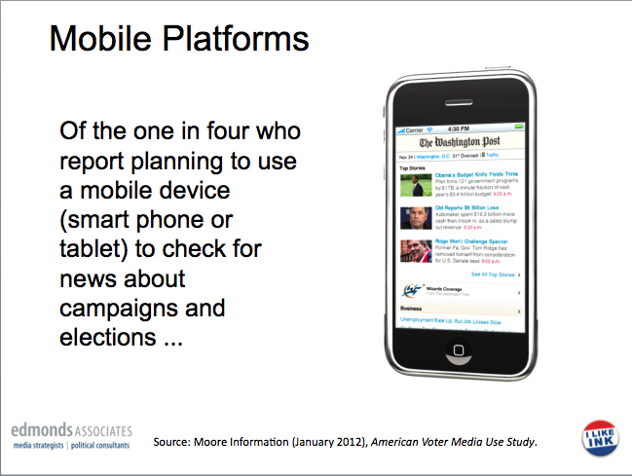

- Track record of impacting swing votes for key elections

- Highly visual – voters associate name with a face
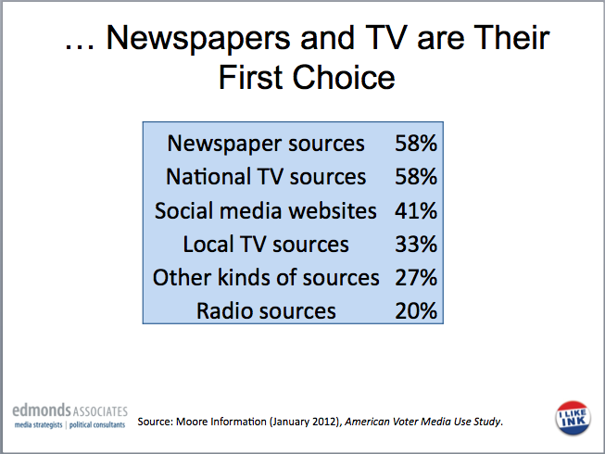

- Pricing, packaging and selling

Key go to market strategy consultants advise media companies to include the following:

- Dedicated sales staff with all campaigns covered. Identify people on the team who are passionate about selling the political category and will support the effort with an early start. A passionate head start makes a big difference. If managers have an organized effort – ie good packages, leads lists and competitive training – a dedicated political team should be able to go to market on straight commission, in addition to what other products they are selling. Or, with more than one dedicated local rep, political races can be divided into Democrat and Republican – depending on the interests of the rep, or State versus Local. Be sure to tap a manager as a team leader.

- Print should lead with new media If you are a newspaper, multi-media levels the playing field so, lead with new media. This is the easiest way to play to your strengths if you have a great site and get a foot in the door. Radio sites can package in geo-targeting text alerts and email for last minute get-out-the vote events.

- Political multi-media rate cards. Consultants recommend two simple, three-tiered, multi-media bundles: Small, medium and large, and state, local and issue.

Just like the small, medium and large tiers, special combinations for different kinds of races work well, since they require different kinds of targeting. Each bundle has one price along with national, state, local options adding up to six choices. Buyers can also access a la carte rates for premium buys.

- Use good visuals. Television is great at visualizing ads, and print companies need to do this, too. Get rid of column inch rates and sell modular sizes. Highlight the saleable space (banners, corner peels or mobile ads and text alerts) in red, and provide information online.

- Play up premium buys. This is a great time to sell site takeovers, corner peels and other premium buys. Remember that premium buys like this expand inventory at a time when it may be selling out. Print companies should also focus on presenting cover wraps, front page ads and post-it notes. All media should have a few strong “by the day” buys.

- Be able to handle 1 to 2 day closings. Being able to place an order on a media or media site in 24 hours can mean the difference between getting the buy and losing it.

Let campaigns know they can count on your media at the last minute.

- Case study: Richmond Media Group

One local media company that aced the 2012 elections with their new political ad strategy is Richmond Media Group.

Richmond Times-Dispatch, owned by Media General includes TimesDispatch.com, Richmond.com and Richmond Suburban news. John W. Kelly, VP, Revenue and Business Development headed up the political effort, which also will sell newspaper markets throughout properties in Virginia and Tennessee.
Historically the group underperformed in political ad sales and lacked a well-timed strategy to capture additional market share. The increase in political campaign dollars in 2012 incented Kelly to come up with a new plan that would accomplish several things:
*Increase sales pressure
*Launch an attractive competitive rate structure –
*Use packages and bundles to make buying easer
*Leverage digital
*Sell across the region

Strategy
Kelly’s plan was to take these principles, start early and create superior execution:
• Using The John Kimball Group was the primary source for candidate’s contacts. Kelly says, "This was one of the most worthwhile investments we made."
• Contacting television and radio stations early and often. By law broadcast stations are required to give contacts for their political buys and do so willingly. Kelly was able to find and contact SuperPac dollars early in the year.
• Creating a dedicated team. Richmond created a five person political sales team from existing staff which included people passionate about politics –on the left and right. One key rep was a real estate sales executive. The organization of the team includes a sales manager (with shared responsibilities) , national rep, and three local reps for a total of five people. All these sales positions are paid on straight commission, added to their regular jobs.
• Focusing on competitive strengths. Kelly focused his company to go after the direct mail market, and also to be in position to pick up broadcast dollars whenever they sold out.
• Direct mail. To position against direct mail delivery service, RMG prepared by offering:
*Guaranteed day of delivery
*Print and deliver turnkey solution for geo-targeting
*Free design and quick turn-around.
• Positioning in advance for radio and TV to sell-out. The media group pitches the unlimited inventory - especially for last minute buys - when TV and radio are apt to be sold out. This also worked to pitch large accounts such as auto dealers who stand to be “bumped” off the air when campaign season is in its peak. So either way, more dollars come in.
Also in the pitch – beside the optimal age demographics – are Premium capabilities. Kelly advises, to think “What can you offer candidates in terms of space. We need the money so badly the newsroom rolled over on everything in terms of space, strip ads on the front page, for the first time.”
• Assessing - and building out - political advertising channels: Political advertising is a natural tie-in for news readers. But Media General also has a variety of multi-media opportunities and decided to add partners to beef up its online offerings.
• Partnership with Politifact as an additional, saleable online political news channel. Started in 2011, Politifact is a key news source for people addicted to following political news, runs on the front of the Richmond Times-Dispatch site.
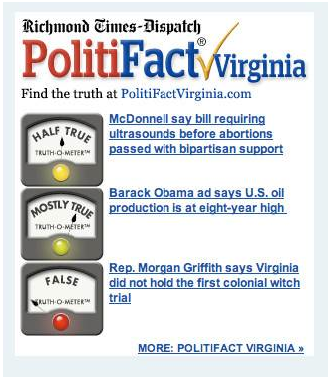
Finally, Richmond lined up a partnership with CityTwist.com an opt-in email provider that allows candidates to blanket a geo-target with both email as well as direct mail.
• Premium Print products include stitched covers, adhesive notes, plastic wraps, direct, door-to-door distribution to compete with the post-office.
Adding on extra digital products for better local targeting. Not just online and mobile, but also email and text alerts were added to provide extra promotional cache. Site take overs and corner peels were important premium offerings.
• One simple message was created to brand all packages. The lead message for Richmond Media Group for political advertisers is "Reach all voters seeking to be informed," which capitalized on print's strength with people who actually vote. Rather than competing head to head with television - the primary source of information on political candidates and issues - the messaging positions the newspaper products as the logical second buy when television sells out.
• Rates were also made more competitive. A mistake many companies make is over-pricing political “call-ins” – usually to national rate cards – without understanding how to utilize more aggressive competitive pricing to steal market share and increase total dollars. Under-pricing the post office is critical.
• Strong visual sales and promotion tools
How media visualizes their case for political spending makes a difference. In this case a flip-book created on the Flipsnack platform is hands down the best multi-media rate card we've seen. Using blocks of red to identify the saleable space / opportunity created a strong visual highlight. The flip book was also re-formatted for a six-page, newspaper print and ads also ran.
The 2012 package included small, medium, large and premium, plus buys for city hall, state, and federal. Note how the expandable ads are key components: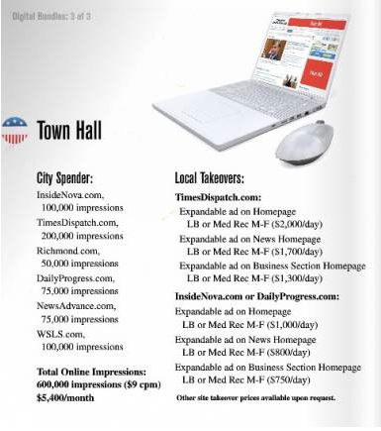

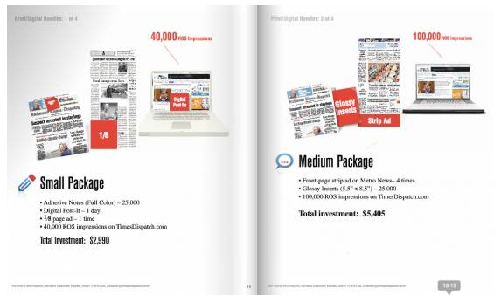
The small package above includes post-it notes, a 1/8th page (note: no column inches!) and 40000 impressions for $2995. The Medium pages include a front page advertisement, glossy insert and 100,000 impressions for $5405.
The large package added a half page to the front page ad - both run twice - plus doubled the impressions and mobile, for just more than $11,000. And the premium package added the corner peel, Spadea wrap and upped the buy to $23,000.
By March RMG had sold $200,000 in political dollars and ultimately doubled revenues from prior years.
The new 2014 flip book can be found at this link.

- Case study #2: Tricks of the trade from the LA Times

We also picked up some key tips from Tom Erspamer, the national political seller for the LA Times. While this is a huge newspaper some its tips and geo-targeting strategies are worth looking at in most local media markets.

• Selling premium products
Like Richmond Media Group, the LA Times takes advantage of all of its resources, especially premiums. One of those strengths is the Spadea wrap, a most powerful "get out the vote" format unique to print.

Plus there is a halo effect: "If you are wrapping our newspaper with a three page Spadea its going to look like we are endorsing you. We get calls from angry readers about why are you allowing so and so to get such visible ad space on LA Times. You can look like you’ve won the endorsement with well-placed ads.”

The LA Times also sold its front page space every day but election day during the peak season. Broadcast and radio sites need to think about what is premium – including site takeovers – that can be packaged to create valuable one or two day propositions.

• Ad units that stream social media are another premium up sell. Streaming live Twitter and Facebook feeds into a banner ad is a product that Impact Engine sells and provides political marketers with a new, sexy multi-media vehicle to expand their social media voice to additional markets in a targeted way.

• Reselling mobile text and emails. The Times has partnered with a company that developed 150 million text and e-mail opt-ins, allowing it to resell this form of messaging to political marketers. "The mobile texting and email opt-ins are contracted out. Find out who is selling these and get them lined up in advance. They need us because they have a problem breaking through to the buyers."
E-mail and texts are media agnostic - even radio stations have been highly successful in developing their own lists. Any local media can get in to the targeting business by working through third parties.
• Create multi-media packages for district races. LA has 30 districts, and many of those district races are too small to run television campaigns without a lot of waste. So the group has developed highly targeted packages for each district. They include:
*80,000 text messages and emails
*Banner ads
*Tribune Direct mail
*TMC printed fliers with a QR code.
Price is a key advantage for the fliers, which were 10.5" glossy sheets that are priced at $25 per thousand, printed and delivered, with a QR code. This pricing worked for campaigns, "They (were) used to paying $700 just to print a postcard."

• Contacting TV stations - and repurposing video ads online using a quick turn-around video-to-web platform. A standard best practice for selling political ads is to contact every television and radio station to get the contacts and spending levels. LA Times goes a step further by preparing to repurpose the video ads for the web on-the-fly using Mixpo.
- Conclusion
For markets with under-developed political strategies, here is a summary of how to create a plan that could double revenues in 2012:

- Start now.

- Identify all the races.

- Have a dedicated team.

- Package multi-media buys – and keep it simple.

- Consider content partnerships.

- Consider adding email and text for additional geo- and voter- targeting.

- Create big, “by the day” premium buys such as site takeovers.

- Be able to execute orders over night.

- Resources:
Political contacts: John Kimball Group, john@johnkimball.com, 703/669-2507.
Content partners: poltifact.com
Email opt-in partners: citytwist.com, Take5solutions.com, consumerbase.com
Rich media ads: ImpactEngine.com provides a platform that builds premium ads such as corner peels, sliding billboards and Twitter ads that can be deployed in minutes by a trained production person.
Video-to- web conversion: Mixpo.com converts video to multi-media
Consulting: Tom Edmonds, Edmonds and Associates, tedmonds@edmondsassociates.com, 703/448-8000

