Green Paper
How to win
the local wedding
franchise

Introduction – Why own the wedding franchise
There is no reason why every media needs to own the wedding franchise, but there are some good reasons to do so.
The wedding industry is a rich franchise where disposable income spent in a hyper-compressed period of time.
Brides invest a national average of $27,000 – spending which largely comes to a halt 14 days after the wedding. 85% of brides go online to plan their wedding.
Key advertisers survive or thrive on this revenue, including venues (not just chapels, but resorts, hotels and other venues), jewelers, wedding dress and tuxedo providers, high-end restaurants, florists, caterers and travel companies who sell tours.
Secondary merchants include cosmetics, teeth whitening, massage and even new auto and homes.
Strategically, the bridal category reaches a core audience on the verge of a major passage to adulthood, still forming brand – and media – preferences. Typically, people getting married move intio a double income unit and are able to buy houses, cars and major appliances with greater disposable income. As such they are also a major market for home furnishing companies.
So as a media company, it’s a great way to secure a relationship with a new and important audience.
However, there is also more competition than ever before – from The Knot as well as local and out-of-state promoters bringing events into your city and taking over the bulk of the revenue.
This report focuses on how to win, based on field-tested best strategies from local media that have done it. By the end of the report, you will understand all the major components of the most successful strategies, with great ideas to borrow in each category.
The five core strategies to monetize the wedding category discussed in this report include:
1. Merchant contests
2. Engagement announcements in print and online
3. Wedding sites with real local content
4. Local bridal magazines or special supplements
5. Events and Expos
Taken separately, large wedding expos, yield the most revenues. But wedding initiatives that win the category combine some or all five of these elements.
So what do merchants really want from media? Is it the web site? Is it the magazine?
The best way to think about the deliverable - ie what merchants want – is current leads for brides, and, within that very important and very short window, a chance to interact with them.
The media that win the franchise have both an engaged relationship with the audience of brides and the ability to convert them to leads and interactions with merchants.
Thought of in this context, wedding and engagement announcements provide content for niche sites, but also a relationship with brides that will attend events, participate in contests and who can be converted into leads.
This report focuses in on winning tactics for these core five components as well as how to put them together to win the franchise. To delve more deeply into any of these examples, find them at LocalMediaInsider.com/weddings. This report extrapolates the best ideas from all of the case studies on the site.
1. Wedding contests
The easiest way to monetize the category and power-up an audience of brides is holding contests.
The best contests aim at pre-wedding brides and capture high-value registrations of people before they get married.
Prior to the wedding brides are in top spending mode. Once the wedding is over, brides will still spend on home set-up, and the family will continue to spend, but a large chunk of their investment in getting married is already made with 14 days after the wedding. Leads for brides are the number one raeason that merchants buy booths in events – it is the leads list, not the booth that is the most important take away.
While there are many “Dream Wedding” contests nationally, to create a list of brides, a simple wedding giveaway in reality is giving away the venue and food. So if you can provide the leads to the venue – and provide an opportunity to interact with brides – they will pay to advertise the contest and share the leads. It’s all about ROI – ten weddings equals $100,000 to $270,000 in new business so there is a lot to work with.
Look for great local venues with a big objective - such as doubling weddings during the year.
May, 2014's Top Ads Winner, Lake Lanier Island Resorts (case study at: http://www.localmediainsider.com/stories/Dream-Wedding,1223) created by WSB-FM, for example, was intended to make money, not secure a franchise. But it shows how valuable these leads are and powerful a contest can be; it generated 500 leads and sold ten weddings for the venue, plus booking $30,000 in promotional dollars at the station.
Keys to this initiative included:
• A single, motivated advertiser with a clear goal of doubling weddings during the year of the campaign, to put up the prize.
• A significant media buy on multiple platforms. $30,000 was the total spent between radio, online, Google and Facebook ads.
• On-air promotions that got the audience involved in voting on all aspects, from the top three couples and the winner, to the choice of wedding dress and onsite place to hold the ceremony.
• An after-party for all the contestants on site resulted in 50 brides to be visiting the premises for a cocktail party. This is critical – the chance to interact that merchants are looking for. Did the venue receive some sign-ups? You bet. Keep bridal cocktail parties in mind – as we will see later – as an alternative to a full-blown expo.
To see the step-by-step how to for The Dream Wedding Contest use this link.
Combining contests with other initiatives
The best way to leverage contests long term, however, is to tie-in contests with a least one other initiatives such as an event, magazine niche sites or channel.
Media that run a wedding expo often require vendors to post a prize for “day of” giveaways, and/or contribute to a larger contest as well (think of a dream wedding with 50 prize elements from the dress to the flowers!). The extra prizes incite more interest in in the event, and more brides means more leads for the booth vendors in a virtuous cycle.
We've seen up to 500,000 page views and 25 merchants provide gifts for a big Dream Wedding, in conjunction sales of bridal booths at an expo.
Contests for content
If you company is committed to winning the franchise, it needs a site with great local content – and contests are also way to get this done.
Simple sweepstakes always tend to get the most votes and leads. However, content-oriented contests may be necessary to provide content for a brides website, magazine or on-air broadcast. So include these in the mix.
“My FairyTale Proposal” or “Our Story “ are tried and true contest concepts that gather usable content for niche sites and magazines.
VowBride, a magazine and site, uses it’s “Our Story” content as the basis for a column, Kim’s White Album, that profiles local couples.
The profile also includes all the vendors, planners, color schemes, etc. the couple used in their wedding – great for leads and easy to do.
Media that publish engagement announcements, can simply add a list of questions that prompt brides to tell their story to enter a contest on a thank you page or email.
Remember to always use a checkbox to contests to identify brides who may be willing to share with a media’s writer - or be added to a mailing list for offers to brides.
Remember – it’s not enough to have the traffic and sign-ups for the contest, you need the ability to turn an engaged audience into leads for merchants.
Thinks of new content-oriented contests outside the box of traditional weddings. The timing may be ripe for a gay wedding contest in San Francisco or other progressive cities. This sector is under-served by mainstream local media and wedding marketers may be eyeing this new and lucrative category. See the My Big Gay Illegal Wedding contest sponsored by the ACLU as an example. It's slogan: Take a stand for love and you could win a trip to New York City. Why not invite gay brides from a neighboring state where weddings are not legal to a contest based on getting married in your state?
On the other hand, Ted Hollo, director of sales at WBTN 1370 AM in Vermont, says that since his DMA is "over-ridden with Duck-Dynasty (types)", he has had this idea:
"One of the tuxedo rental offerings now includes a camouflage vest and tux jacket with camouflage lapels; so my idea was to give away a redneck wedding replete with all the 'good ol' boy' accoutrements." Burlap sack dresses for the brides?
The marketing department turned it down for obvious reasons. The point, however, is to think outside the box but stay local and just broad enough to get enough entrees.
Post-marriage contests
Post-marriage contests create content for sites and magazines in the off-season, and develop an after-market of people who renew their vows or make secondary purchases of rings.
Post-marriage contest ideas from around the country that have succeeded include:
• Wedding song play list (especially for radio stations, but can be posted on line as well).
• Best Wedding Photo
• Wedding gown contest)
• Best Wedding Vows and Renew Your Vows
Keep in mind that niche sites will absolutely need some off-season content that feeds merchants with leads, so this is a good one to consider.
For the full list of wedding contests that made it past our editors and a step-by-step "how to create a wedding contest" click here.
2. Wedding and engagement announcements
Basic to the bridal category are wedding and engagement announcements. Now that so much information is online, other media besides newspapers are running announcements. Online announcements can have unlimited color images, and tell longer stories such as ‘how we met’ and ‘about our wedding.”
Many television sites are now running these for free, in an attempt to get a foothold.
Even if just a few leads a week makes a difference to a jewelry store or venue. One TV station has a merchant paying $850 a month for a display ad in return for the 2 to 3 leads a week from a low traffic turnkey wedding site. So think carefully about the ramifications for using free or paid listings.
Make sure to have a check-box for brides that want more information on bridal specials from merchants – so these announcements convert to those super-hard to find, high ROI leads. If your media has a digital agency, combine with a e-newsletter on behalf of your bridal merchants.
For simple listings, a quick order-taking platform that integrates print and online to monetize announcements is Celebrations, created by self-serve software developer Wave2Media.
The upside - and downside – is that it also includes other celebrations such as birthdays and anniversaries. So it’s really more of an order-taking platform with built-in pricing and packaging.
You can see how it looks at these links:  Raleigh News & Observer, Raleigh, NC , The Sun News, Myrtle Beach, SC,  Idaho Statesman, Boise, ID and below, at the Virginia Pilot:
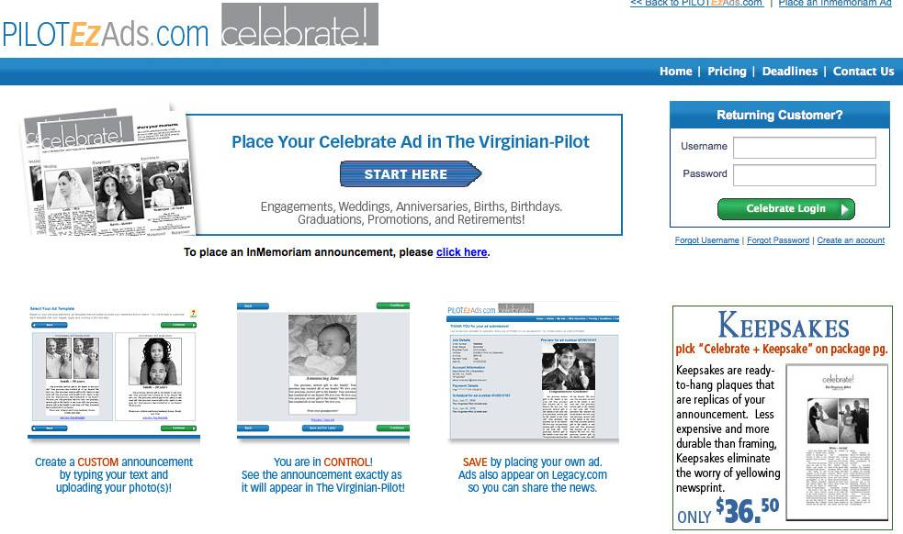
The Virginia Pilot also has a separate and unrelated upscale bridal niche site, whose online announcements are written in a more extensive profile form, including a list of “how we met” and vendors selected by the bride: The best of both worlds!
3. Online niche sites and content channels
Just having a wedding site in and of itself will not win the franchise, but a real site or channel is important to establish the brand and create a place for ongoing interactions, display ad and native content all year long.
The media that have driven the most revenue from the bridal category actually started with an local expo and backed into a content channel. Remember, merchants want leads and interaction much more than branding.
However, having a great content channel and brand makes all the other strategies and tactics work better.
A new local brand can work well for this category since newspapers and television are more associated with news. So we recommend at least a look at creating a strong brand, such as “The Pink Bride” that ties thematically to audience aspirations – as well as to expos and magazines.
Either way, the content for a brides channel or site needs to include local weddings and be aimed like a lazor at what brides want – ideas getting their wedding together.
A combination of user-generated content, plus national and local curated content works well.
In this case, user-generated content simply means announcements and postings.
The popular “Real (insert name of area) Weddings” content, can be user-generated via contests in the off-season for images of weddings, and/or co-mingled from similarily formatted native content from paying venues (see Boston Weddings magazine below).
National content also helps because it’s relatively inexpensive and surprisingly well done.
Just try asking a newsroom to write up wedding specific content and wait for the blow-back. On the other hand "canned" content lacks a local feel.
So a good combination often mixes both, but is heavy on the local content.
To provide some pre-packaged content, one resource is ContentThatWorks, which also offers a a turnkey white-label bridal platform, Brides 365, that updates compelling wedding-oriented content daily.
The ContentThatWorks material is written in sharable style (“Tips for picking unique, meaningful wedding readings,” “Rustic Wedding Style,” “Fresh ideas for favors,” etc.) and can also be used simply as content for a column or magazine, or to supplement local fare.
Native advertising shines here – any one of these ideas can be fleshed out with images and wares from local merchants.
Local images also avoids a clip-art look and feel. Best practice is to use ALL local couples in the wedding and engagement photos – although we continue to see many sites that do not follow this practice!
Some media use a full ContentThatWorks platform, with varying mixes of local/national content. Here’s the version from WCTV.TV:
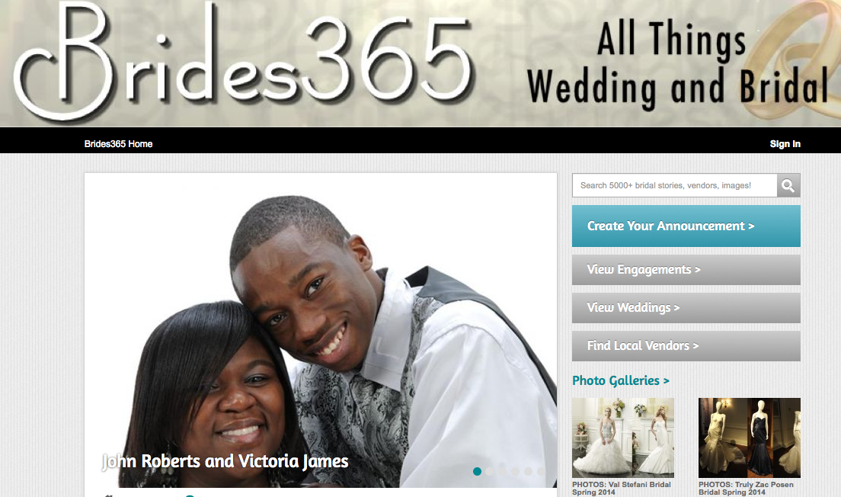

This white-label, turn-key platform has with some nice built in touches:
•Display advertising units
•Engagement announcement-taking with enhanced upsells
•Options for turn-key magazine publication
•The ability to post local content inside the mix
•A self serve vendor directory as a value-add or separate purchase
Typical retail pricing of the channel at WCTV.TV includes $875 month for a presenting sponsor and $195 a month for exclusive by category ads, paid monthly.
The WCTV.TV site sold $30,000 in its first ten day sale, but stalled out as other priorities emerged. One year later, only the title advertiser remains, primarily in order to obtain the two or three leads per week.
Lesson learned here: Turnkey sites do not flourish on their own, nor do they generate significant revneues. They need infusions of local content, plus traffic and revenue builders such as contests, expos and magazines, to drive results and deveop new revenue streams.
Best practice is also to sell ads in conjunction with larger targeted wedding-oriented buys.
Many – if not most – of the turnkey platform sites we looked at also had house ads in banner positions.
This was not the case however, with media that have more active wedding strategies – expos, magazines and contests .
So without these components, and a lot of local user-generated content, a niche site is not going to secure the franchise and may become frustrating to sell.
Below is example of a slightly better effort at radio group who white-labeled (the first step in the right direction) a Brides365 site in Vermont and Northern New York as "Unveil your Wedding.”
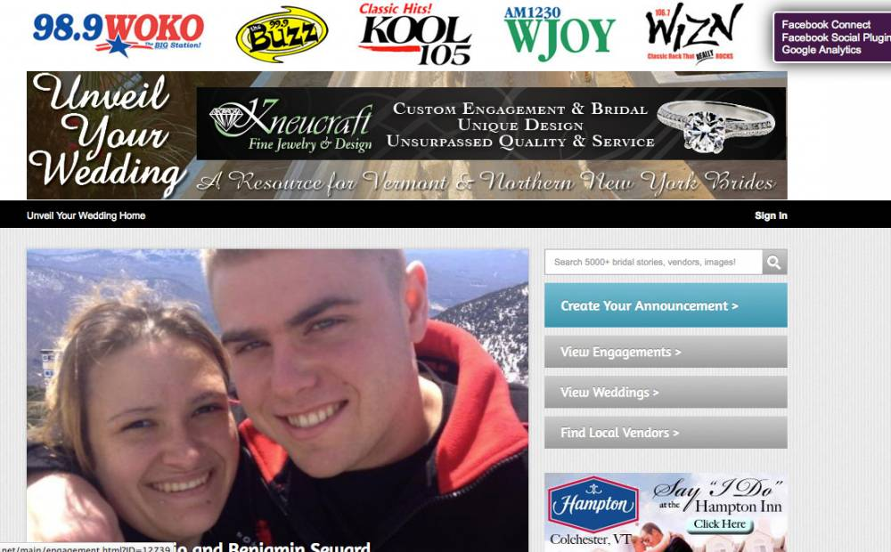
This station also hosts a small bridal expo featuring some of their advertisers (list of exhibitors is here) and a revenue-generating contest. Note the prominent leaderboard sold to a jeweler.
LubbockBride.com, a version created for a group that includes Fox34 news, uses their Facebook page to promote a Wedding Gown contest, and the top display banner to congratulate people who have announce and share their stories.
The Chattanooga Times Free Press
The above strategies are making inroads, but the local company that may be taking the most revenue out of the wedding category is the Chattanooga Times Free Press, who started building the category with six figure Bridal Expo a few years ago.
Today they have a new competitor worth looking into, a customized site, The Pink Bride,and also a magazine, on a platform powered by RealWeddings.
ThePinkBride.com brands itself as “Tennessee’s Leading Wedding Resource.” The site includes images from real local weddings, inspirations and tips (in an area called The Pink Press), and ecommerce for expo tickets, plus bridal sunglasses and T-shirts:
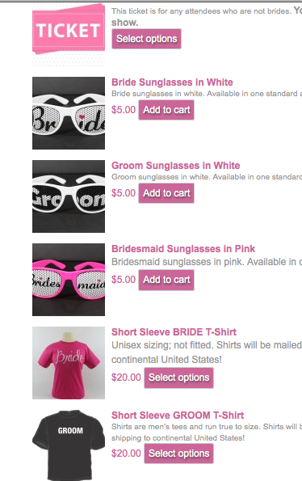

Steal these ideas!
VowBride, a similar channel and magazine, created by the Virginia Pilot has had similar success with a similar strategy.
The Virginia Pilot’s Vow Bride features a column, “Kim’s White Weddings” in the navigation bar, which is just a “How we met” paragraph on a couple, with a list of vendors – more ad leads!
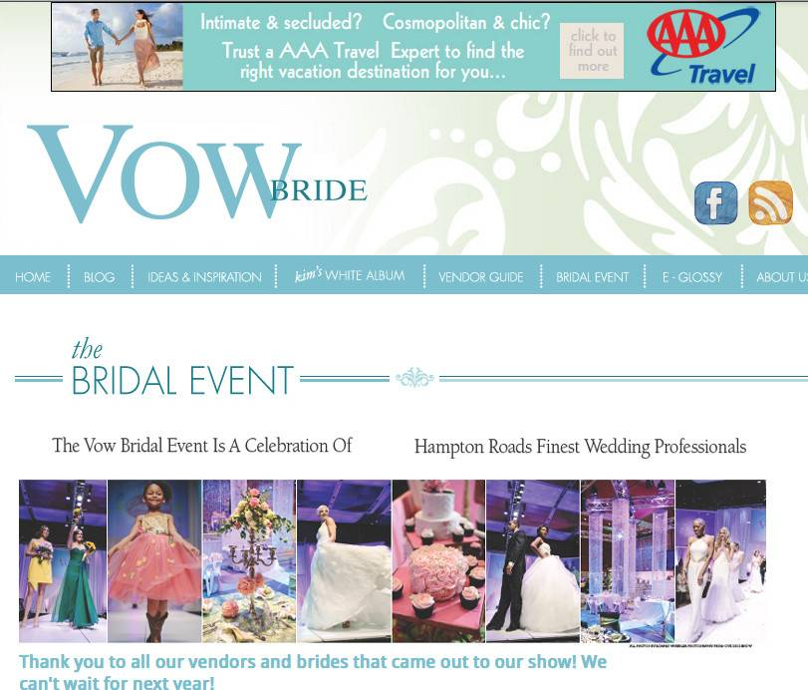
But the marquis show-stopper for these brands is the big wedding expo. No matter what the wedding strategy overall, plan to build some kind of event/s – small or large – into the mix.
3. Bridal events
Bridal events may be the sleeper in most markets, and the most under-estimated component of a bridal strategy.
The most significant revenues from the wedding franchise as a whole are in the events category, a category often usurped by out-of-state promoters.
It is no coincidence that the two of the outstanding weddings sites, The Pink Bride and VowBride, also house great expo promotions and after-images, so the events build all year long.
The Chattanooga Times-Reader has taken the bridal event franchise back - and now makes more six figures with a 70% profit margin in five different markets. Find the full step by step case study on how they did it is here.
Before undertaking a bridal event, make sure you have at least one separate staff person devoted to the event full time for a period of time, even if it is just two to three months. Here is a summary of Best Practices from the Chattanooga case study:
• Assess the competition, usually an non-media promoter.
Do they have an adequate web site, substantial vendors and media partners? How happy are the local merchants? A simple phone survey can find out.
If the event is especially strong, consider partnering to sell booths. Promoters typically spend 30% promoting events, so if you can save them this investment in another media, it could be a win/win.
You can also produce the program, or create your own smaller, boutique event.
But keep in mind that the 30% expense on promotions is also an advantage to the media company.
Chattanooga made the assessment and decided to take on the out-of-state competitor after merchants in the category said they would support a more local expo.
• Appoint an event producer with P&L responsibility. They will need a P&L template, created in advance, and nothing else to do but events.
• Create the prospect list.
They include wedding planners and bridal boutiques, but also venues, caterers, florists, jewelers, invitations, photographers, cosmetics, tanning, teeth whitening, massage and spas, salons, travel, auto and new homes. For a complete list of vendors sold click here.
• Select a centrally located venue, with adequate parking that can accommodate vendors and activities.
These events are not as big as, say, a Women’s Expo, but need enough space for a fashion show, a stage for announcement, a back area for vendor refreshments, as well as other activities such as a Wedding Taste tasting by a celebrity chef. Chattanooga started with about 125 vendors and lot of activities.
Plan to have a pre-party to walk vendors through the venue, so line up food for the pre-party and the vendor lounge.
Select a color scheme from a notable event design provider. Chattanooga’s black and pink theme translated into the booth tablecloths, signage, and goodie bags, to finally become the magazine brand, The Pink Bride.
Also make sure there is sufficient sound and light to accommodate activities.
• Plan activities and a celebrity draw. What about a wedding cake contest or wedding gown fashion show? Celebrities and activities are a key to make an event the best one in town.
• Set the pricing for booths and tickets. Typical pricing ranges from $700 for a 1x1 booth to $3000 for six 20x30 booths. Brides get in free, while other attendees typically pay $5 to $7 at the door. Expect most of the revenues to come from the booths, followed by ticketing, and sponsors.
• Make sure to include a list of registered brides (they register in a separate line day of event) as part of the vendor package. That is a lot of what they are paying for – the list, not just the booth. Since brides get in free, having them register in a separate line is the easiest way to make sure you have their contact information – this can also serve as an entry to the big dream wedding contest.
• Create a contest for best booth. This works well for all expos, and is worth doing.
• Over-staff the event day of. For a 1,000-attendee event with 150 booths, Chattanooga has a staff of 30. A pre-event meeting goes over ‘what will happen.” Set-up is the day before – so that’s a requirement for the venue.
• Day-of focus on the brides. Not just a separate registration, but a goodie bag and something to identify them - a pink ribbon or bracelet will do – will help make them feel special and allow merchants to recognize and single them out for special treatment.
• Include an event floor plan, contract, packages, and booth contest in the vendor area on the web site. Also use photos from prior year to sell the event.
Flowers are important. Some great flower arrangements can often be supplied by the flower store in trade.
Below is a great website image of the Cake Boss from reality TV's judging the wedding cake "bake off" during a Chattanooga’s stellar bridal fair:
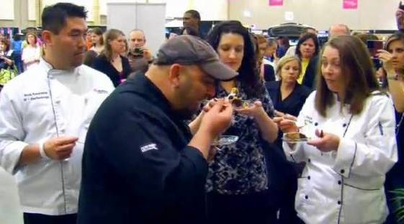
Like the Chattanooga show, VowBride’s event is content rich: There is a contest for "best booth," a give away of a wedding band, fashion show and celebrities.
Smaller events
Even big media companies, such as the Boston Globe, don’t always take on producing expos. Boston Weddings magazine opted for some small events that leveraged the brand, including:
• Luncheons with the editor – These are held a couple of times a year for industry professionals to meet the editor and find out more about both the “earned media” (ie free) editorial opportunities as well as piad content.
• “Best of” cocktail parties with brides. Current brides were excited to be invited to meet merchants who made the “Best of Boston Weddings” list.
Mall Fashion Shows are also popular and easy because people are already at the mall, and the mall itself can be a sponsor.
4. Bridal magazines
The Virginia Pilot and the Chattanooga Times Free Press -understand the powerful organic relationship between magazines and events.
The Pink Bride magazine competes with Chattanooga in five markets around the area – so make sure you know your enemy!
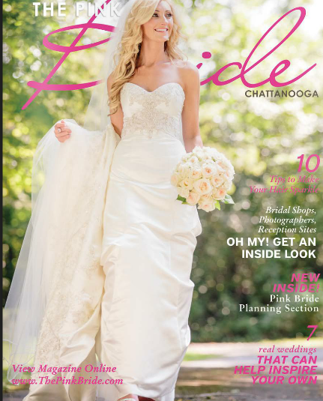

VowBride is one of 32 different magazine title published by The Virginia Pilot.
Like high-end home remodeling services, brides are a category where the glossy upscale look of a magazine also works better than newsprint and where local magazines can have a national feel.
Best practices for magazine publications:
• Publish twice a year. No need to publish monthly. Once a year to start, in January, before a bridal fair and just before the spring wedding season is ideal. Add a second magazine when the time is right. The Boston Weddings formula is spring/summer and fall/winter.
The Viginia Pilot’s VowBride Magazine (see their flipbook here) also comes out twice a year in January and July, with January’s edition schedule in time to promote their February bridal fair.
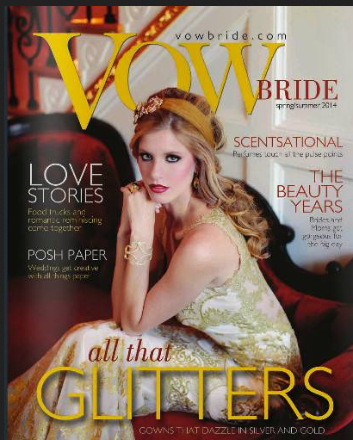
• Off-season content for magazine includes wedding images from the season, vow renewal, and planning materials. VowBride hosts a wedding image contest that supplies content for the summer issue of the magazine.
• Native advertising can be advertorial or hybrid, directly paid or value-added. A great list of native advertising features comes from Boston Weddings:
- Real Boston Weddings allows venues to post images from real weddings onsite along with contact information, for a price
- “Love that” allows merchants to post images along the lines of that issue’s theme – typically fairly broad, such as autumn wedding.
- “Local talent” introduces readers to planners, caterers, and other experts in specific destination areas.
- “Ask an Expert” is a sort Q&A of someone who specializes in an area of wedding support
• Play up the writers as serious lifestyle journalists and the market will take them seriously, too. Boston Weddings is a master at promoting its editor’s image and background, even on the media kit. Magazines are visual, so make a big deal of your great team.
• Publish a minimum of 10 to 15 % of the circulation. Distribute in high-end locations, but especially to wedding planners, venues, merchants and registries (don’t forget Macy’s), and, of course, the expo and events.
• Add ¼, ½ and full pages in the magazine distributed prior to (and at) a bridal event as upsells to booth vendors and/or sponsors.
Putting together the plan
By now you should realize how well these five components combine to attract brides and convert them to leads for merchants.
If you have a magazine brand, it can be the brand for the weddings area, incorporate engagement announcements and contests and promote bridal events. Or some newspapers have selected to add content to their engagements and announcements page – along with contests and events.
Events yield the most revenue, but booth sales serve can be tiered to include display ads in the pre-show magazine, contest sponsorships in the off-season, and presence on the niche site.
Here are some tips to locate your starting point and move into strategic planning
- Build on what you have, but create a long-term vision and road map
If your company has an events division or weddings announcements, start there – but look at what it will take to win.
- Research the competition. Competition is the most important factor in your plan. Assemble a list of wedding expos, magazines and sites in your area. Interview sales reps who have wedding accounts, and, finally, do a telephone survey of the wedding-oriented merchants to find out what they want, need and will support.
- Get buy-in from top management – but start with a money maker. If your team is planning to win the franchise long term you will need support from management.
Strategies that peck away at building incremental revenues rarely win categories. On the other hand, the reality of media today is that showing revenues first is often key to securing support.
- Don’t launch an event without a dedicated events person. A wedding event is often a great first event for creating a revenue-producing events department, but don’t try to pull it off without an event manager responsible for the P&L of the event.
- Assess additional markets in the long range plan
A factor to consider is the availability of additional markets, once the learning curve has been absorbed and expertise in events, niche sites and magazines gained.
Adapting the plan to other nearby cities could be the difference between, say, $180,000 to $250,000 a year in a single market to more than a million in four or five markets, and also determine whether or not to create a unique brand.
- Decide on whether to brand or integrate
Does your company want to build a brand that fits and integrates into its community site – or a separate state-wide brand with a different flavor?
- Plan an event – small or large. The best month is February. These events put focus into hyper-drive and are the best way to prove revenues.
- House the event from the beginning on a branded website or wedding channel that has all the elements you will need long term – announcements, vendors, bridal content, ad units and a directory.
- Use a contest to launch the site and build the event. Consider a schedule of contests, one aimed toward the expo, one for content, one in the off-season.
- Consider magazine in January. This can support and be handed out – at the event.
- Incorporate images from the event as content for the web site during the off-season to gather interest and leads all year long – and to promote the next event. Plan off-season contests, on-going images of local brides and “real weddings.”
Thanks for checking out our Green Paper: How to Win the Local Wedding Franchise with examples from the top media companies around the country.
For a deep dive into case studies on each of these specific elements go to LocalMediaInsider.com/weddings.
For help creating your plan contact Alisacromer@localmediainsider.com
408.892.9815

